1. IP Address - 199.26.11.8
2. ipconfig /all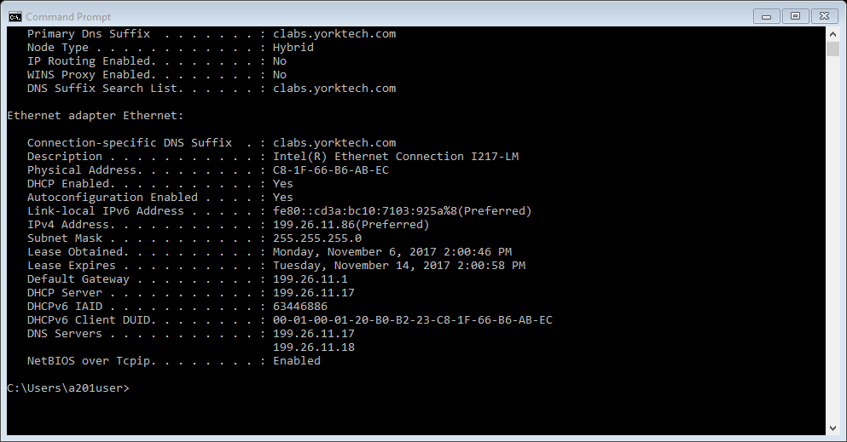
3. tracert google.com

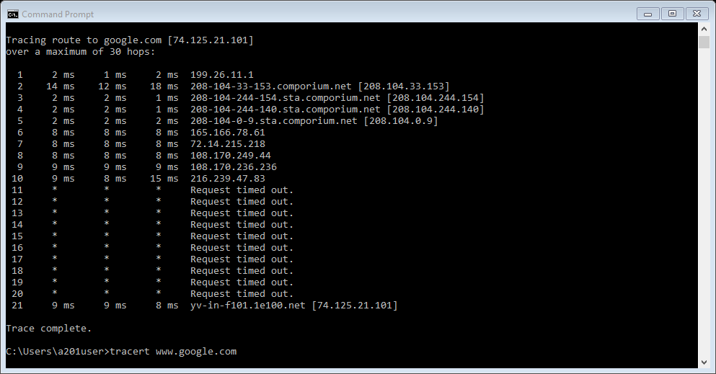

1. route print

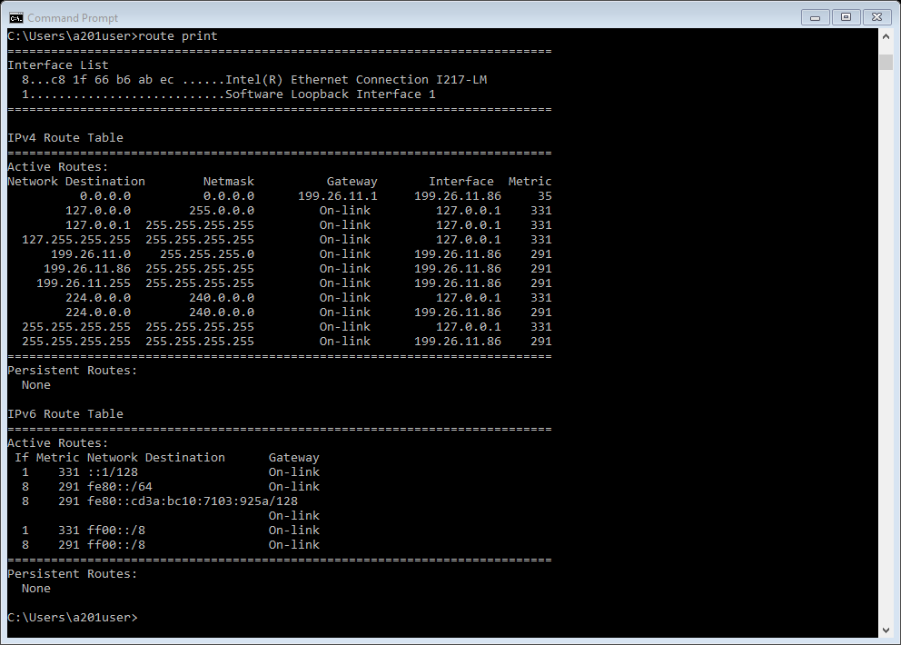

1. arp –a

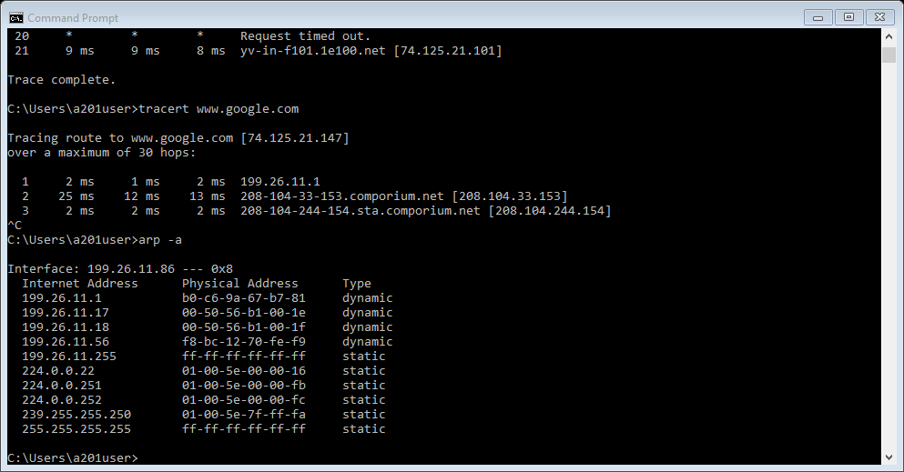

1. ipconfig /displaydns

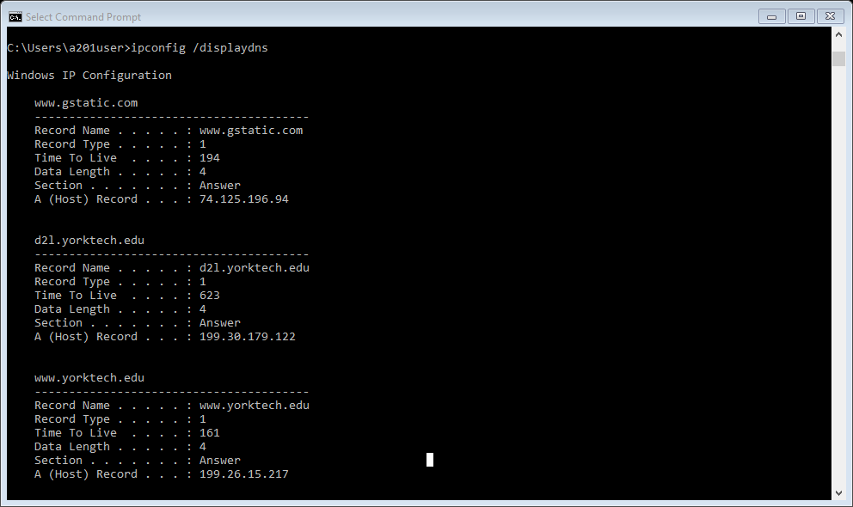

1. sudo dhclient eth0
2. cd /var/log
3. sudo [command]
4. admin password

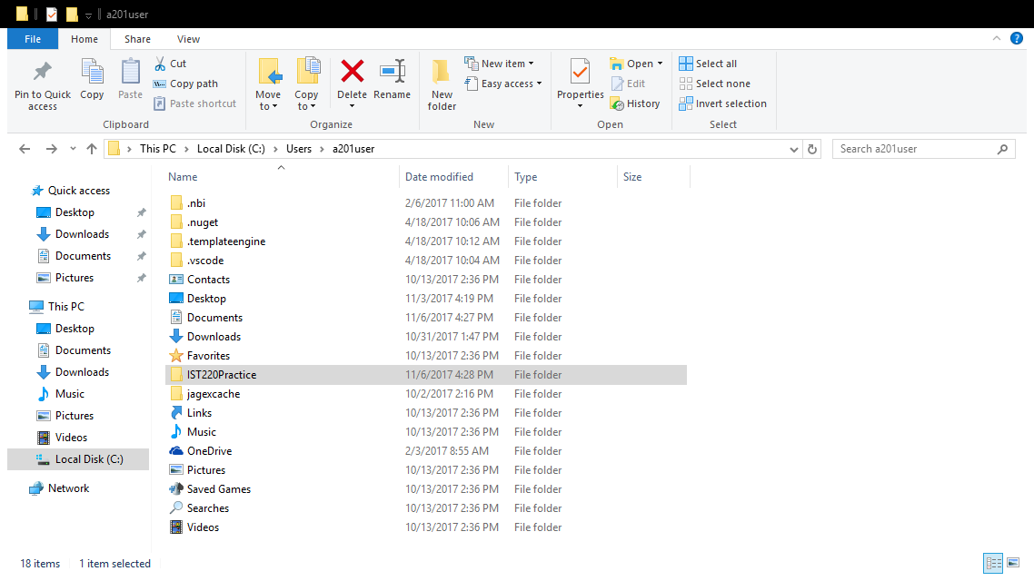

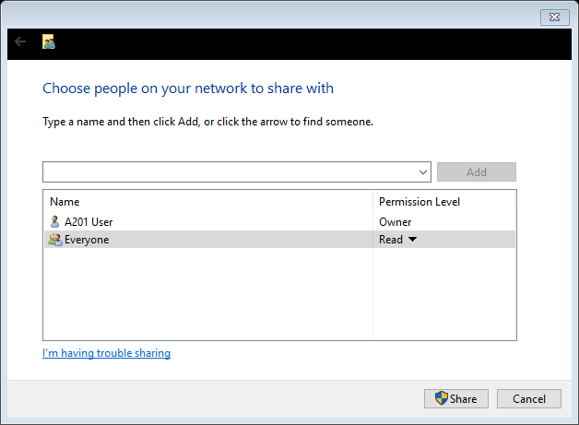

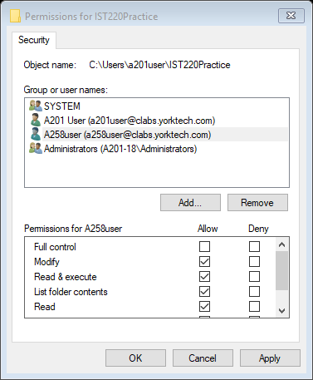

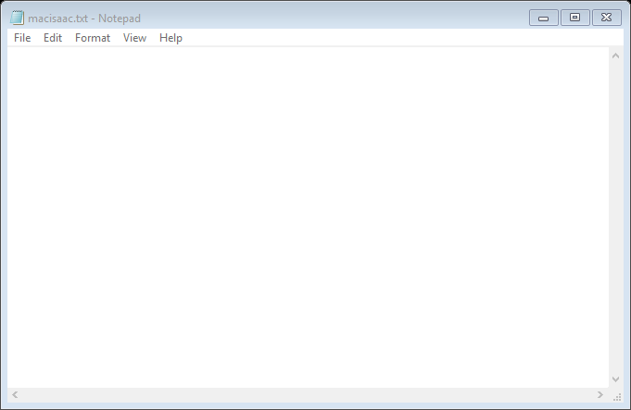

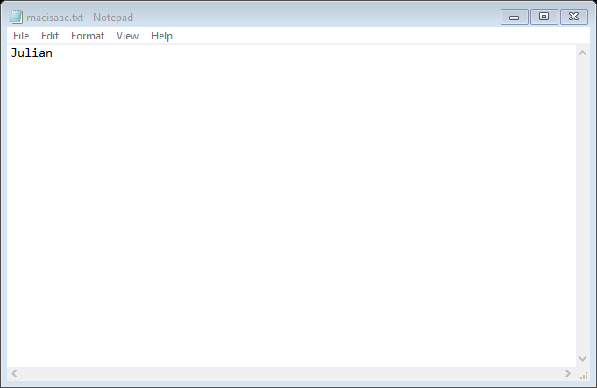

1. Open macisaac.txt properties. Go to Security tab. Click on Edit to edit permissions. Add new user (object) named ISTuser, then click Check Names to ensure you are adding the correct user. Click ok, then with ISTuser selected, check Modify under the Allow column in the permissions box. Apply.

|  |  |  |
| --- | --- | --- |
| **Decimal** | **Binary** | **Hex** |
| 175 | 10101111 | AF |
| 215 | 11010111 | D7 |
| 97 | 01100001 | 61 |
| 56 |  |  |
| 22 |  |  |